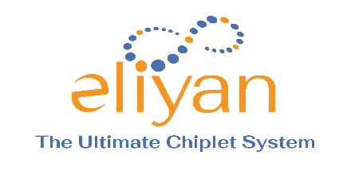
Company Background

The transition from monolithic chips into discrete chiplets results in more powerful systems. The industry no longer depends only on Moore’s Law to provide a path to higher performance, nor relies on process scaling to lower energy at a reasonable cost and complexity. The race to chiplets has put the spotlight squarely on interconnects. Chiplet require new interconnect technology optimized to deliver high bandwidth, low latency, and low power.

In 2016, Eliyan Founder and CEO Ramin Farjadrad developed a breakthrough die-to-die interconnect architecture that leveraged cross-technology innovations to deliver the highest bandwidth and lowest latency at the best-in-class area and power efficiency. Given its exceptional performance and features, this architectural breakthrough received strong support from the Open Compute Project (OCP). It was adopted as the industry standard chiplet interconnect called Bunch of Wires (BoW).

In 2022, the Universal Chiplet Interface Express (UCIe) was proposed and adopted by a broad cross-section of semiconductor industry heavyweights. BoW and UCIe use similar clocking and signaling architectures, define chiplet interconnects for organic substrates and advanced packaging, and are supported by Eliyan’s NuLink technology.

That’s where Eliyan comes in.

Eliyan’s D2D technology began at Aquantia, acquired by Marvell in 2019. Eliyan spun-out with 6+ years of research and production. NuLink™, Eliyan’s PHY solution, delivers performance and power/area efficiency that no other technology can offer. Our exclusive patent-protected technologies deliver industry-standard and custom solutions at twice the bandwidth and half the power.

For more information please contact:
Mike Sottak
mike@wiredislandpr.com
650-248-9597

