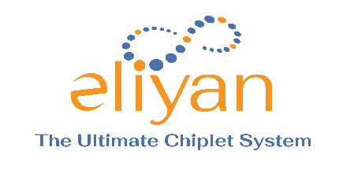
Founder Biographies

Ramin Farjadrad
Co-founder & CEO
Ramin is the inventor of over 130 granted and pending patents in communications and networking. He has a successful track record of creating differentiating connectivity technologies adopted by the industry as International standards (Two Ethernet standards at IEEE, one chiplet connectivity at OCP.) Ramin co-founded Velio Communications, which led to a Rambus/LSI Logic acquisition, and Aquantia, which IPO’d and was acquired by Marvell Technologies. Ramin’s Ph.D. EE is from Stanford.

Patrick Soheili
Co-founder & Head of Business and Corporate Development
Patrick Soheili has been CEO of three early-stage technology companies. He led BD/CD and IPBU at eSilicon, as well as heading marketing, sales, and operations management at Altera, AMD, and TRW. He’s led seed-stage deep technology venture capital resulting in multiple IPOs and M&As. Patrick’s MBA is from Purdue; his Math and Physics BS is from UCSB and the University of Bristol.

Syrus Ziai
Co-founder & VP of Engineering
Syrus Ziai held VP of engineering roles at Nuvia, Ikanos, Qualcomm, and PsiQuantum. He has a breadth of experience in systems, chip architecture, design methodologies, and packaging, and has managed 100+ engineering teams across the semiconductor industry. Syrus’s MS EE is from Stanford. He has 30 years of experience and has developed 11 patents.

For more information please contact:
Mike Sottak
mike@wiredislandpr.com
650-248-9597

